1.)What is React Js?

* React.js, more commonly known as React, is a free, open-source 1JavaScript library. It works best to build user interfaces by combining sections of code (components) into full websites.
* Originally built by Facebook, Meta and the open-source community now maintain it. One of the good things about React is that you can use it as much or as little as you want!

**For example, you can build your entire site in React or just use one single React component on one page.**

2.) What is NPM in React Js?

* NPM stands for Node Package Manager.
* It is a package manager for Node.js, a JavaScript runtime environment that allows developers to build scalable and performant server-side and client-side applications.
* NPM is a vast repository of over a million packages, offering developers access to a wide range of open-source libraries, frameworks, and tools.

3.) What is Role of Node Js in react Js?

Node js provides

* the run time environment,
* node packege manager(npm),
* building and serving applications,
* (server side rendering without page refresh.

Node js playes a important role in React.

4.) What is CLI command In React Js?

* CLI : Command Line Interface
* open your terminal, type this command: cpx create-react-app project-name
* change (project0name) into your project folder name and wait for packeges installation
* then type this command: cd project-name
* this is the last command for run your project: npm start.

5.) What is Components in React Js?

React components are reusable bits of code. There are two types of components

(1)Class components

(2)Function components.

**For example: we need to copy the same part of code in all pages. So we just call that component name in that place.**

Example:

import React from 'react'

function App() {

return (

<div>

<component_name/> //this is component

</div>

)}

export default App;

6.) What is Header and Content Components in React Js?

Header component has top on the web page & Content component is the main component in every single web pages.

In React, header components are reusable blocks of code that construct the top section of a web page, typically containing:

* Logo: A visual representation of your brand or website.
* Navigation Menu: Links to primary pages or sections of your site.
* Search Bar: Enables users to quickly find content within your site.
* User Controls: Login/logout buttons, profile links, etc.

Example:

import React from 'react';

function Header() {

  return (

    <header>

      <h1>My Website</h1>

      <nav>

        <ul>

          <li><a href="/">Home</a></li>

          <li><a href="/about">About</a></li>

          <li><a href="/contact">Contact</a></li>

        </ul>

      </nav>

    </header>

  );}

export default Header;

[Content Components]

it is not commonly used on websites every page. Because of every single page have different content.

Content Component is main component in web page.

* Article components that display text and images
* Blog post components that structure titles, content, and metadata
* Product card components that showcase product details

7.) How to install React Js on Windows, Linux Operating System? How to Install NPM and How to check version of NPM?

/Windows installation:

1 Go to nodejs official website <https://nodejs.org/en/>

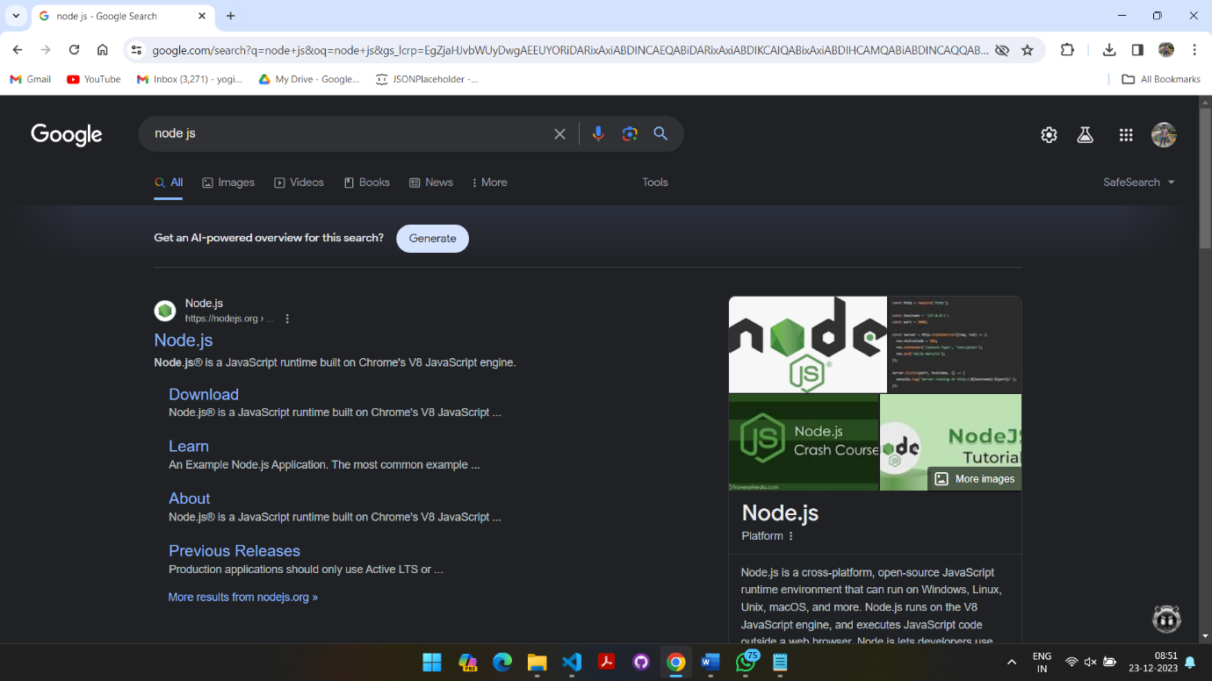

2 Download node recommended virsion and acroding to your windows bit capacity (32bit/64bit)

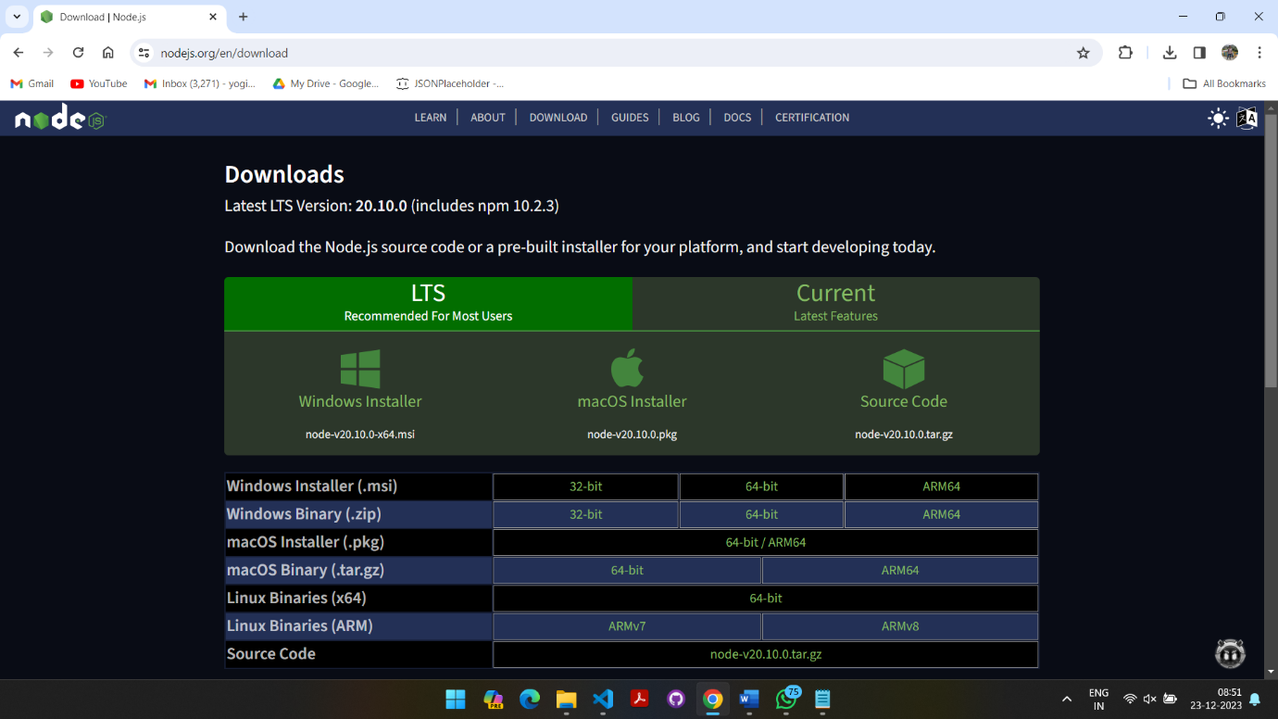

3 Check version in vs code terminal / cmd : (1)node -v. (2)npm -v

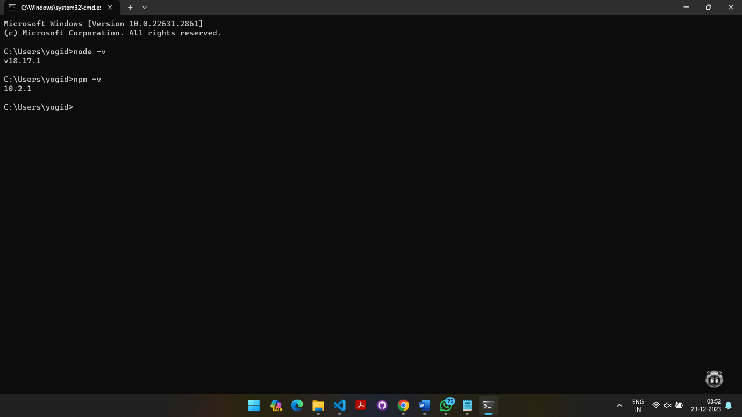

4 Enter commands for new Packege install:

1. npm i -g create-react-app
2. 2) npx create-react-app (project name)

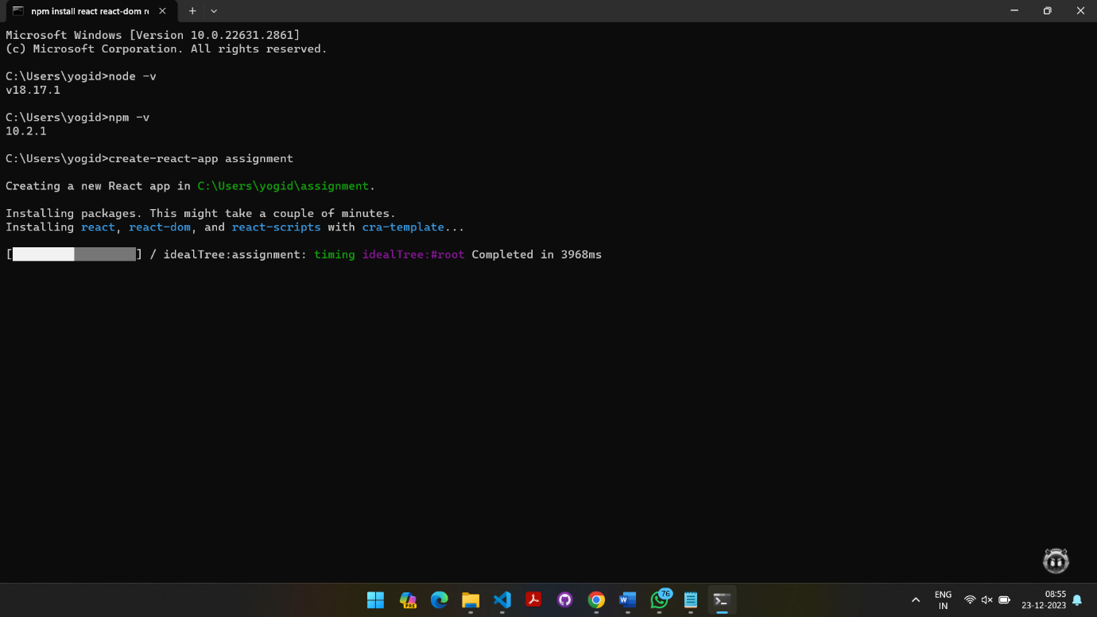

3) cd (project name)

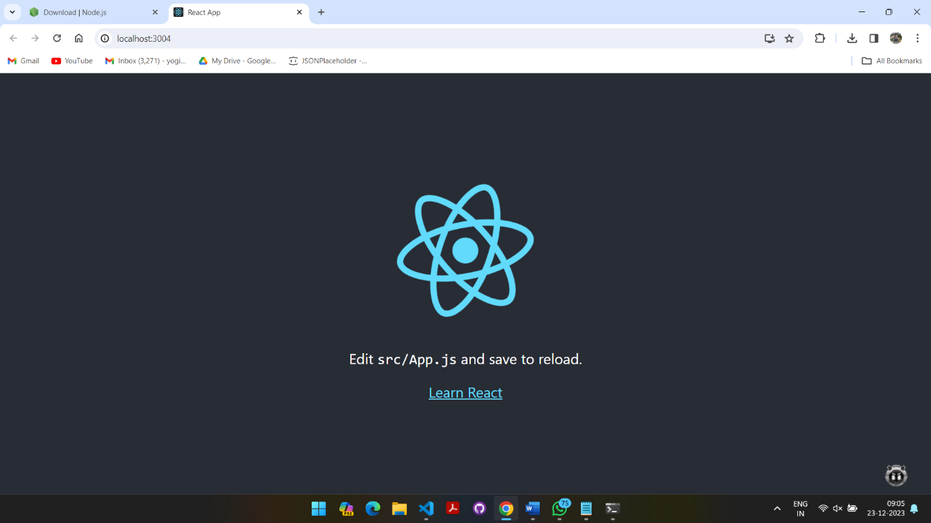 4) npm start

/Linux installation:

1 Open linux terminal and install nodejs by this command:sudo apt install nodejs

2 Check and verify this command:

node -v

npm -v

4 install new project folder with this command : mkdir (project name) && cd project-name

5 install react using this command: npx create-react-app

8.) How to check version of React Js?

Follow this commands for check version of React in terminal.

1) node -v

2) npm -v

9.) How to change in components of React Js?

There are three ways to change in components of React;

1) edit component's code

2) props

3) states

(1) edit component's code: If we have to change the component's design/ layout any more different changes we should directly change the code.

(2) props: We put props in the function component's parameter as we need and then give props value in "App.js" or any other component.

Example:

function Function_component ({props}) {

<div>

<h1>This is {props} example</h1>

</div>

}

(3) states: we put state in the function component. Here is a Example

Example:

import React, {useState} from 'react'

function Function_State() {

    let [name,setName]=useState("change");

  return (

    <div>

        <h1>This is {name} component</h1>

        <button onClick={()=>setName("un changed")} >Changed component</button>

    </div>

  )

}

export default Function_State;

10.)How to Create a List View in React Js?

React List wiew is here:

**Function_component**

Car.js

import React from "react";

import ReactDOM from "react-dom/client";

function Car(props) {

  return <li>I am a {props.brand}</li>;

}

// created function through which list is rendered.

export default function List() {

  const cars = ["Ford", "BMW", "Audi"];

  return (

    <>

      <div>

        <h1>The React way to Render a list.</h1>

      </div>

      {/* passing value of cars to list car. */}

      <ul>

        {cars.map((car) => (

          <Car brand={car} />

        ))}

      </ul>

    </>

  );

}

const root = ReactDOM.createRoot(document.getElementById("root"));

// rendered a list

root.render(<List />);

App.js

import Car from "./Components/Car";

function App() {

  return (

   <Car></Car>

  );

}

export default App;

11.) Create Increment decrement state change by button click?

import React, { useState } from 'react';

const Car = () => {

 const [count, setCount] = useState(0);

 const increment = () => {

    setCount(count + 1);

 };

 const decrement = () => {

    setCount(count - 1);

 };

 return (

    <div>

      <h1>Count: {count}</h1>

      <button onClick={increment}>Increment</button>

      <button onClick={decrement}>Decrement</button>

    </div>

 );

};

export default Car;